
PT1/CSQP/1123/A 01-MAY-2023
PERIODIC TEST - I (2023-24)
Subject: COMPUTER SCIENCE  Grade: XI |  | Max. Marks: 35  Time: 1 Hr 15 Mins

General Instructions

1. This question paper has 4 pages.

2. This question paper contains five sections, Section A to D.

3. All questions are compulsory.

4. Section A has 9 questions carrying 1 mark each.

5. Section B has 8 Very Short Answer questions carrying 2 marks each.

6. Section C has 3 Short Answer type questions carrying 3 marks each.

7. Section D has 2 questions carrying 4 marks each.

8. All programming questions are to be answered in Python Language only.
 | SECTION A |  |  | (9)
1. | In hexadecimal system, each alphanumeric digit is represented as a group of __________ binary digits. |  |  | 1
 | - 1 |  | - 2
 | - 2 |  | - 4
2. | Which of the following is a common standard used for character representation in computers and commonly used for encoding schemes? |  |  | 1
 | - Coding |  | - ASCII
 | - ISCII |  | - UNICODE
3. | input( ) function always return a value of ____________ type. |  |  | 1
4. | Which of the following is not correct about python?
 | - Developed by Guido van Rossum
 | - It is an open source language.
 | - Case sensitive language
 | - None of the above
5. | Which of the following sequence is correct to convert decimal number to binary.  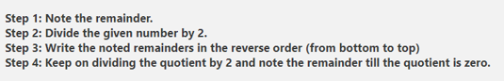 |  |  | 1
 | - Step 1, Step 2, Step 3, Step 4
 | - Step 2, Step 1, Step 4, Step 3
 | - Step 3, Step 2, Step 1, Step 4
 | - Step 2, Step 3, Step 1, Step 4
6. | All statements in python are terminated by semicolon. (T/F) |  |  | 1
7. | Which of the following will occupy more memory space? |  |  | 1
 | - 1111 (binary number)
 | - A2 (Hexadecimal number)
 | - 12 (Octal number)
 | - 10101 (binary number)
8. | Which of the following is not in python character set? |  |  | 1
 | - Letter: A-Z or a-z |  | - Digits: 0 - 9
 | - Whitespaces: blank spaces, tab etc. |  | - Images: Vector
9. | This is an assertion and reasoning based question. Mark the correct choice as:  - Both A and R are true and R is the correct explanation for A  - Both A and R are true and R is not the correct explanation for A  - A is True but R is False  - A is false but R is True  Assertion(A):In python program variable a and A both have different significance.  Reason(R): Python is case insensitive language. |  |  | 1
 | SECTION B |  |  | (12)
10. | What are literals in Python ? How many types of literals are allowed in Python |  |  | 2
11. | Write the names of all Standard Data Types. |  |  | 2
12. | Write a program to convert the given time in seconds into hours, minutes and seconds. Example  time= 3980 sec  The time is 1 hour 6 mins and 20 secs |  |  | 2
13. | Write a program to swap two number using a third variable. |  |  | 2
14. | Write a program to accept diameter and find the area of the circle |  |  | 2
15. | What is the hexadecimal equivalent of the octal number 751? |  |  | 2
 | SECTION C |  |  | (6)
16. | Write a program that asks the user to enter their name and age. Print a message addressed to the user that tells the user the year in which they will turn 100 years old. Eg:  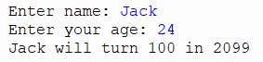 |  |  | 3
17. | Identify the invalid variable names from the following and specify he reason also.  - m_n  - unit_day  - 24Apple  - #sum  - for  - s name |  |  | 3
 | SECTION D |  |  | (8)
18. | Priya is a class 11 student. She is learning python. She wants to display only the last two digits of the given number. She has written the partial code as following:  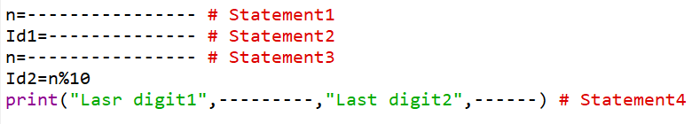  - Statement 1 – Input n as integer  - Statement 2 – Get the last digit using appropriate arithmetic operation.  - Statement 3 – Get new number by removing last digit using appropriate arithmetic operation.  - Statement 4 – Print the last digit 1 and last digit 2 |  |  | 4
19. | Do the following Conversions:  - (BCAI)₁₆ - (?)₂  - (2306)₈ - (?)₂  - (4052)₁₀ – (?)₁₆  - (1111000)_{2 - (?)10} |  |  | 4
***

